# User and Service-Centric Product Workflow Example

I wanted to share the Product Owner techniques I am using as the OTU Website product with our Coaching Community of Practice.

## Summary

Within our organization, Product Owners are handing projects from Business programs. In this sense, POs look like Business Analysts writing requirements. The remainder of this document outlines how a PO can use modern User and Service-centric techniques to manage a Product-oriented backlog and mature out of the pseudo-BA requirements-writing model of product ownership.

## Assumptions

### We are using scrum

The following team worked together implementing the Scrum framework.

### Stories, Product Backlog Items and PBIs

I use these three terms interchangeably within this document. In all cases, I mean a user-centric actionable challenge that serves the need of an audience segment.

### This is the Product Owner point of view

And I am focused on the core responsibilities of the [Scrum Guide Product Owner role](https://scrumguides.org/scrum-guide.html#product-owner), summarized as creating, communicating, and ordering the backlog items with transparency and clarity. While the scrum guide emphasizes these expectations, it does not tell you how to achieve what it calls “Product Backlog management.” The remainder of this document outlines the approach I have used to manage the product backlog, from discovery to sprint inclusion.

## Managing Product Expectations

As a PO, I identified 11 key categories of impact for the identification and management of a product backlog. I worked with the key stakeholders in a series of meetings to outline the key factors found in the below categories.

### Role Participation

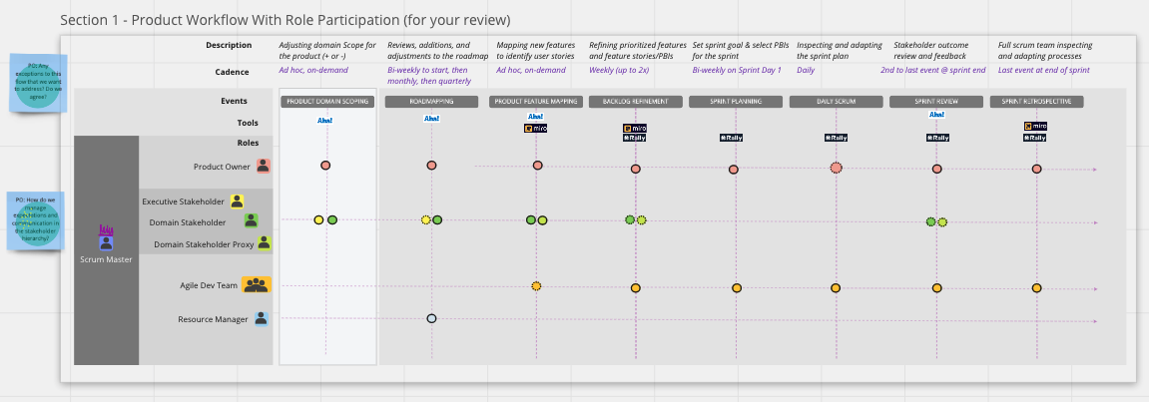

I started by onboarding the stakeholders so we all shared a transparent expectation for what roles are critical at certain times, as well as some advice on activity anti-patterns to avoid. The focus, however, outlined a commitment by stakeholders to either be available to the PO and Scrum team during discovery, backlog refinement, and during sprinting on PBIs.

### Role Expectations and interactions

Next, I worked with stakeholders so they understood the Scrum events and allowed the group to identify questions about their involvement in the process. In the above example, I clarified that as a PO I would focus on answering questions for the team in as close to real-time as I am able rather than distracting the team with insights during the Scrum team’s Daily Scrum. No additional questions came from stakeholders during the launch.

### Role concerns for missing information or interactions

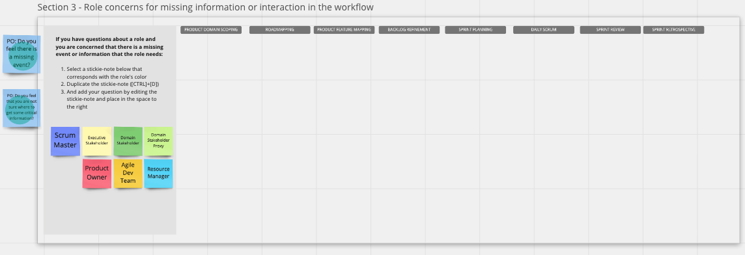

It felt important to give the stakeholders a moment to reflect on any concerns (required stakeholder involvement or limitations) they might have. Our stakeholders were experienced with Scrum and did not have many questions. In retrospect, they could have asked more questions about how they are involved during the sprint or in the Sprint review – based on questions and concerns that have come up during team formation and sprinting. My recommendation is, treat this as a living document.

### Product Workflow Working Agreement

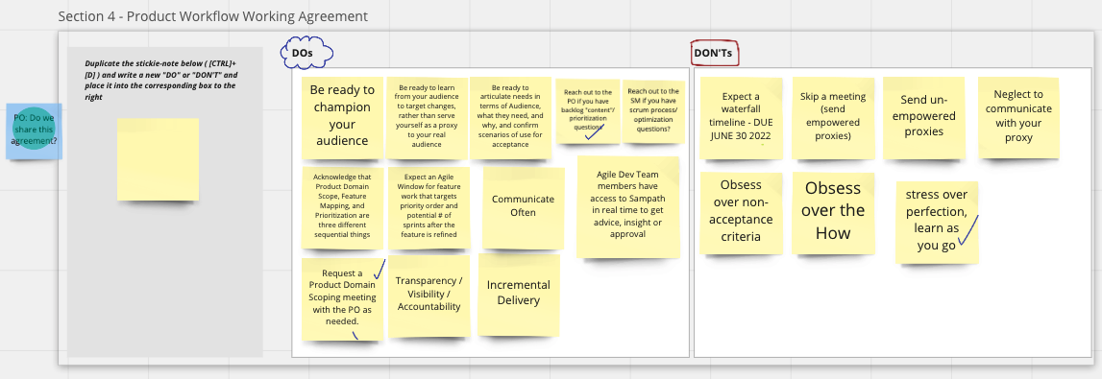

The output of the process, expectations, and concerns led us to documenting a PO-Stakeholder Working agreement. The stakeholder group identified shared expectations around identifying needs, defining the scope of their product service on the site, participating in audience identification, as well as limiting their need to obsess over how solutions are shaped or non-acceptance criteria.

### Product: Optum Tech University (product and service)

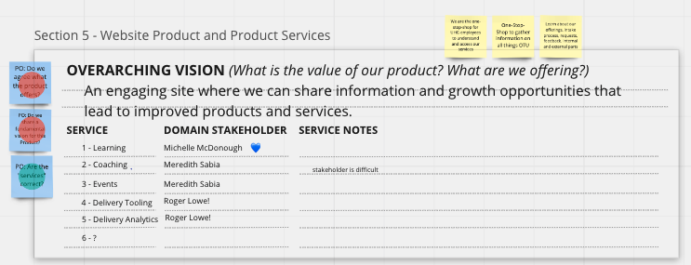

Now that the working agreement and stakeholder and PO roles and expectations were established, it was time to begin to draw specific scope for the website. The stakeholder team identified 5 different service areas (Delivery Tools and Analytics were later re-combined as they are viewed today) and lead stakeholders were identified.

The group worked for a few sessions to focus the vision of the product we were launching. The vision for the Website product inevitably became subordinate to the natural hierarchy of vision: UHG > Optum > OTU > OTU Website.

### Proxy Domain Stakeholders

I asked the group to focus on their service domain and reflect on the working agreement commitment to participate in backlog discovery, be available to product backlog refinement to answer questions, as well as remain available during the sprints that contained their actionable backlog items. With this context, I requested that they select empowered proxies to participate and represent their interest to ensure we could make progress quickly. A number of the stakeholders named proxies immediately.

### Partners

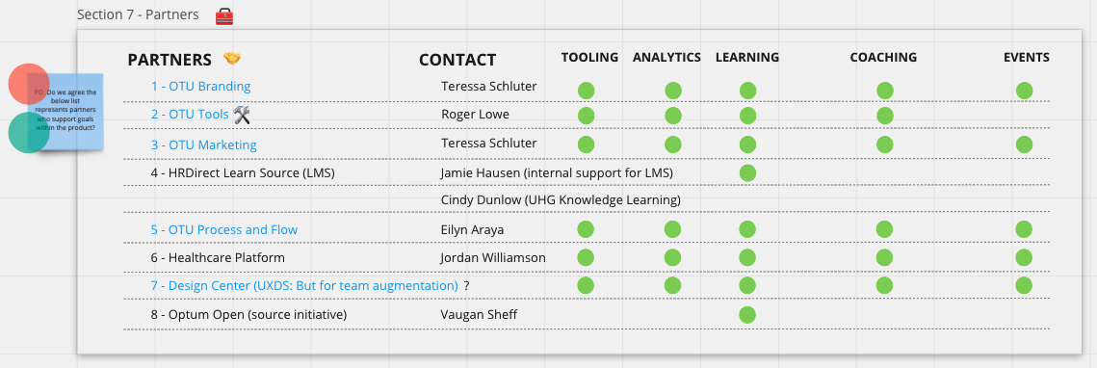

We then reviewed partners for OTU. I asked stakeholders to define service partners as well as partners that created or managed content or standards that OTU was required to work with going forward. Different partners were identified along with the key contact stakeholder that managed that partner relationship. And then we created a matrix to show if a partner held a cross-functional impact or relationship to more than one product service area. As you can see OTU Branding has an impact on all services, while the Optum Open Source initiative relationship only had an OTU-Learning impact.

### Audience Personas

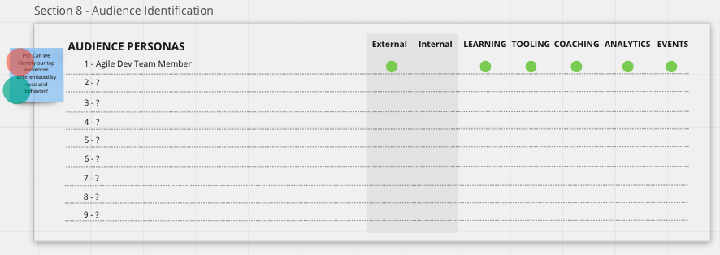

Now that we had established the scope and impact of multiple partnerships, we explored existing audience personas that might already exist. I presented an initial audience (the Agile Dev Team Member) and we discussed if that persona had a vested interest in one or more OTU Web product services. There were no existing explored personas so we added that to the backlog discovery agenda to explore later.

### Product Goals

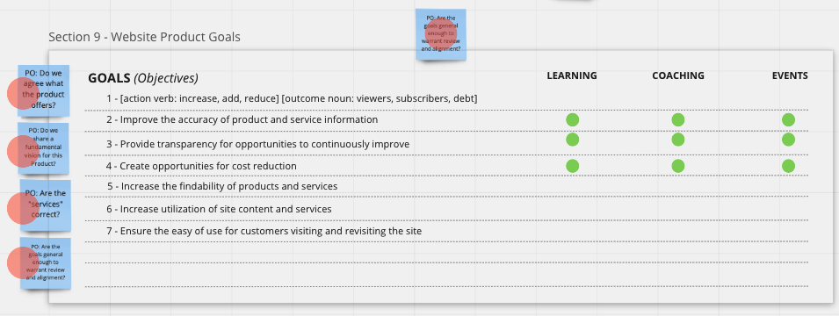

Finally – I asked the stakeholders for the OTU Website product, to establish some starter goals. They identified 7 initial goals, many of which focused on User Experience improvements to be explored across all OTU Website Product service areas. We then began creating a matrix to determine if the first few goals were shared across more than one service area. This gave clarity to help us know where to start exploring and discovering our backlog.

Shared Initiatives

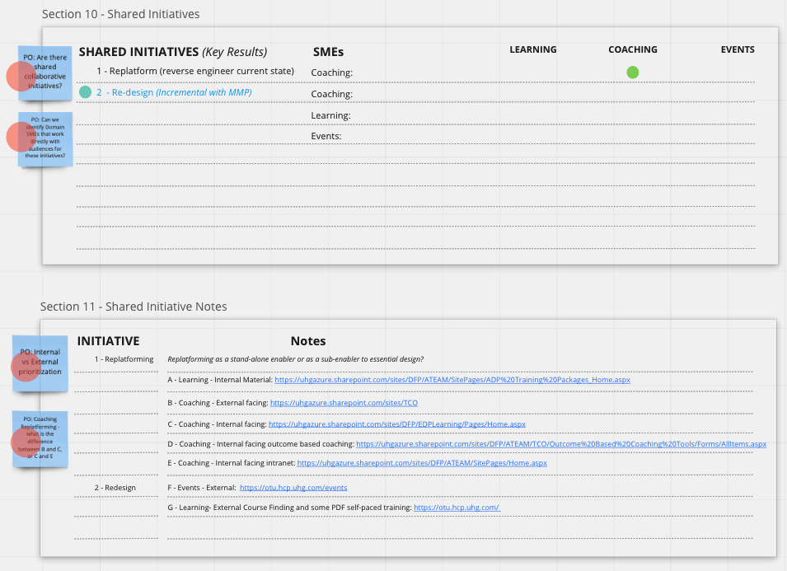

Before going in to Backlog discovery, I asked for any existing initiatives I should be made aware of so we could determine if we needed to incorporate or align any existing initiative expectations and unify the backlog. Two were generally identified:

1. The existing website needed to be replatformed so the new team could inherit ownership and begin making changes to it.
2. There were short-term goals to launch a space to advertise the newly branded and unified Optum Tech University, which would play host to a newly developed video along with basic cross-departmental OTU marketing information so people visiting the microsite could easily understand all of the basic services of OTU.

## Product Backlog Discovery

It was time to start finding the backlog. In many products without UHG there are a list of projects that have been created by various business programs and those projects outline prescriptive technology-focused changes that need to be made in existing product.

In our case, the current website only focused on OTU-Learning services as well as the highlighting of a number of events. Coaching as well as Tools and Analytics services were not listed at all. So the backlog discovery challenge include:

1. Identifying audiences for each of the 4 service areas (learning, coaching, events, Tools & Analytics)
2. Identifying the journey each audience takes to discover our services, engage with our services, get engagement support, and disengage from services. Within the journey context different service and information touchpoints are identified to target the scope of different scrum team sprintable outcomes.

It was critically important that Backlog Discovery not include solutioning. The goal of Backlog Discovery is to determine needs and challenges for each audience segment that would require solutions to be determined by the teams, later on.

### Proto-Personas for each audience segment we serve

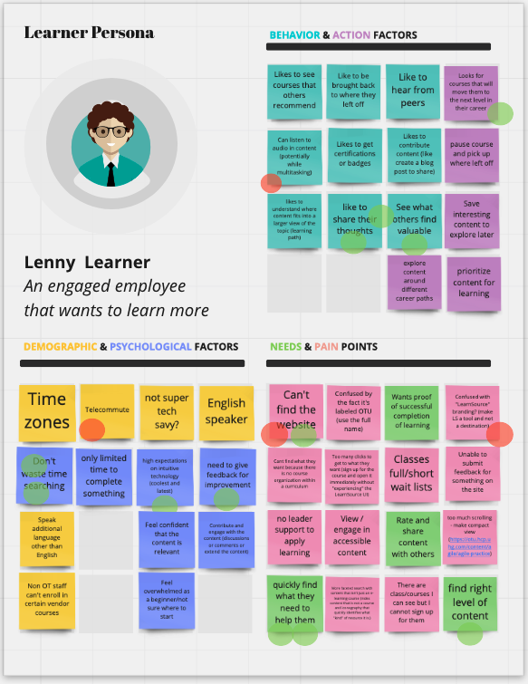

Above is one example of a proto-persona identified during backlog discovery. A proto-persona is different from a marketing research persona in that it is both limited in scope of identifying behavioral factors as well as being considered an emergent document.

Traditional personas require general and specific forms of User Research in order to identify statistically significant factors that correlate an audience segment’s interests with their behavior. That research may include some qualified research, but the focus is quantified research.

With proto-personas, we establish stakeholder assumptions about a limited scope of differentiating behavior based on their expert opinion of an audience segment. Their historical experience aims to answer the following questions:

1. Demographic factors affect their behavior: example could be the timing of certain behavior based on geography
2. Psychological factors affecting their behavior: example could be expectations placed on the audience segment persona by managers/leadership
3. Direct Behavior (stuff they do): example could be that they plan our their day in great detail
4. Action Factors (decisions they make): example could be managing budgets or creating content
5. Needs and Pain Points (pains and gains): General needs that either alleviate a pain or amplify a benefit.

The expectation here is that each proto-persona is emergent over time, where new insights are tested and lessons are learned. Different assumptions can be flagged as highly-important or risky (if the assumption is wrong, then work connected with the assumption could derail the effectiveness of multiple items in the backlog). We used red dots to highlight which assumptions seemed potentially risky. Green dots meant the stakeholders felt completely confident with the stated persona factor.

### Journey Map for each Proto-Persona

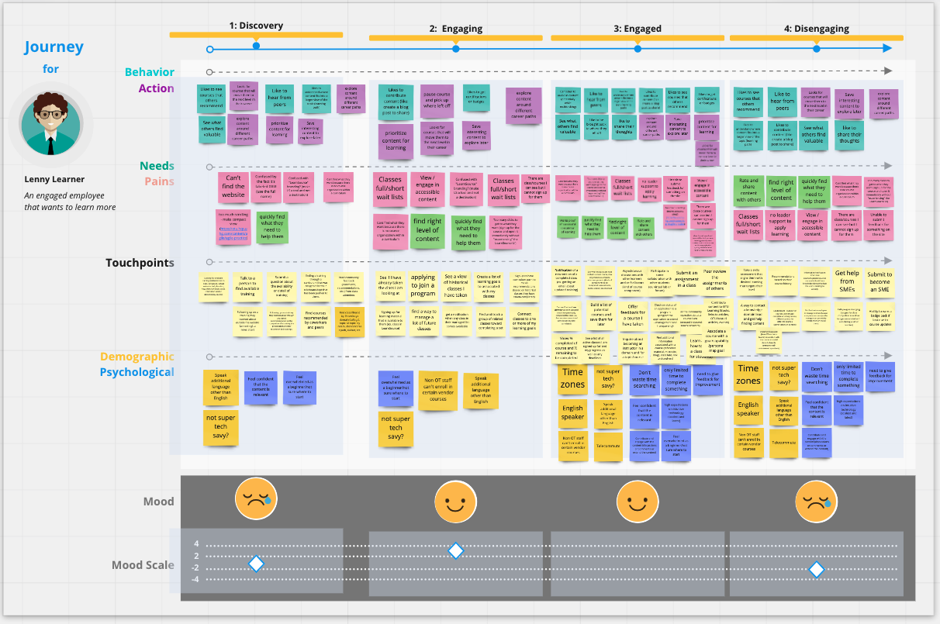

Next, we took the proto-persona and we identified the journey categories that outlined the states or modes the person moves into and out of as they relate to a specific service area. These became the initial columns in the journey map.

Next, stakeholders looked through the persona factors to determine which factors might apply to that particular persona state. For example, if the persona for a learner has a pain factor about scheduling their attendance in classes, that behavioral factor would not apply to discovery, but could apply to the engaging state. Aligning factors with each column created a view of the state of mind for the persona and helped the stakeholders identify what goals or touchpoints might exist for the persona in that state.

The touchpoints section of the journey mode is where stakeholders wrote questions or goals in the voice of the persona. For example, if a learner is in discovery, they have the goal “talk to an OTU-Learning staff person to find training quickly” and this becomes a touchpoint by documenting it in this column.

### Backlog Creation from Backlog Discovery

Like I shared above, across much of UHG, a traditional technically oriented project often turns into a “Capability” backlog item in the Rally portfolio. A subset of technical functionality turns into a feature. Stories to create that feature (technical or otherwise) are created to focus on delivering a functional feature.

My goal as the PO here, is to present a user-centric, service-oriented backlog to the team. We are not looking to create pages. We are aiming to address specific challenges.

To achieve this kind of backlog, I am using Rally to create a feature that addresses a column of a persona’s journey. For example, the Learner Discovery column contains nine touchpoints. Learner Discovery then becomes a feature in the backlog. Each touchpoint starts out as a single user-centered product backlog item.

Again, I want to emphasize that the backlog is not filled with tasks or defined solutions, but rather challenges for targeted personas. Only then, does the team refine the stories, explore their solution approach, and attach estimates for producing an in-sprint solution. If they cannot target an approach because the backlog item requires more research or there are multiple competing solutions requiring validation at some level before proceeding, then refinement creates more PBIs for research (Spike) or to deliver a real test into production.